**Setting Video As Desktop Wallpaper:-.**

1. Open VLC Media Player. If you don't have it download it frome Here.

2. Then Go to Tools > Preference Or press CTRL + P and Selecet Video from left panel

3. Then Choose DirectX video output from output dropdown list as shown in below image.

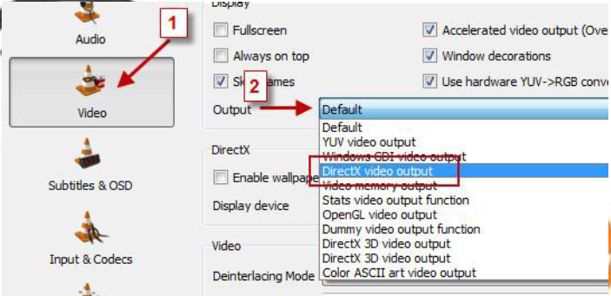

4. Save the changes ans restart VLC Media Player.

5. Play any video you would like to set as your desktop wallpaper.

6. Then click on Video and select DirectX Wallpaper from the dropdown list as show in below image.

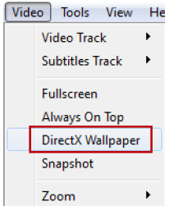

7. Now Minimize vlc player and you will see your video running on your desktop as wallpaper.

8. If you want your default wallpaper back then uncheck DirectX Wallpaper from video dropdown list.

9. Hope you like this simple trick share your thought about this trick in comment section.